CO3-AT3
NAME:S.JAYASHREE
REG NO:192471041
Question: Explain why wait(), notify(), and notifyAll() are defined in Object and not in Thread. Relate your answer to the monitor model of Java synchronization.

Aim
To demonstrate why wait(), notify(), and notifyAll() are methods of the Object class rather than the Thread class, and to understand how they work with Java's monitor (synchronization) mechanism.

Pseudocode
Create a shared object

Thread 1:
Lock shared object
Print "Waiting..."
Call wait()
Print "Resumed"

Thread 2:
Sleep for 2 seconds
Lock shared object
Print "Notifying..."
Call notify()

Start both threads

Program
class Shared {

public synchronized void waitMethod() {
try {
System.out.println("Thread 1: Waiting...");
wait();
System.out.println("Thread 1: Resumed");
} catch (InterruptedException e) {
e.printStackTrace();
}
}

public synchronized void notifyMethod() {
System.out.println("Thread 2: Notifying...");
notify();
}
}

public class Main {

public static void main(String[] args) {

Shared obj = new Shared();

Thread t1 = new Thread(() -> {
obj.waitMethod();
});

Thread t2 = new Thread(() -> {
try {
Thread.sleep(2000);
} catch (InterruptedException e) {
}
obj.notifyMethod();
});

t1.start();
t2.start();
}
}
Output
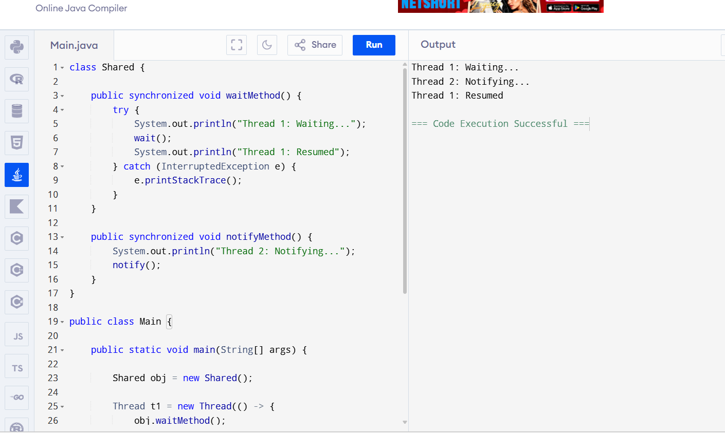
Result
The program successfully demonstrates that:
- wait() releases the object's monitor and pauses the thread.
- notify() wakes the waiting thread.
- These methods belong to the Object class because synchronization is based on an object's monitor, not on the thread itself.

